Reporting Layer – View Dependency Map
Overview
This project implements a three-tier architecture for the Data Warehouse:
- Tier 1 – Base Views (DSO Layer)
- Tier 2 – Summary Views (InfoCube / Aggregation Layer)
- Tier 3 – Report Views (Presentation / BEx Layer)
Each view in the higher tiers is built on top of views from the lower tiers to ensure modularity, reusability, and improved performance.
Tier 1 – Base Views (DataStore Objects)
View Name | Depends On
vw_base_sales | fact_sales_orders, fact_order_line_items, dim_customers, dim_products, dim_categories, dim_sales_reps, dim_regions
vw_base_returns | fact_returns, fact_order_line_items

Tier 2 – Summary Views (InfoCubes / Aggregations)
View Name | Depends On
vw_summary_sales | vw_base_sales
vw_summary_sales_category | vw_base_sales
vw_summary_customer | vw_base_sales
vw_summary_customer_returns | vw_base_sales, vw_base_returns
vw_summary_product | vw_base_sales
vw_summary_product_returns | vw_base_sales, vw_base_returns
vw_summary_returns | vw_base_returns, vw_base_sales
vw_summary_rep_period | vw_base_sales, dim_date
vw_summary_quota_quarter | fact_quotas

Tier 3 – Report Views (BEx Query Layer)
View Name | Depends On
vw_sales_executive_summary | vw_summary_sales, vw_summary_quota_quarter
vw_customer_360 | vw_summary_customer, vw_summary_customer_returns, rep_customer_assignments, dim_sales_reps
vw_product_performance | vw_summary_product, vw_summary_product_returns
vw_rep_performance_scorecard | vw_summary_rep_period, vw_summary_quota_quarter
vw_monthly_trend | vw_summary_sales
vw_returns_analysis | vw_summary_returns, vw_summary_sales_category

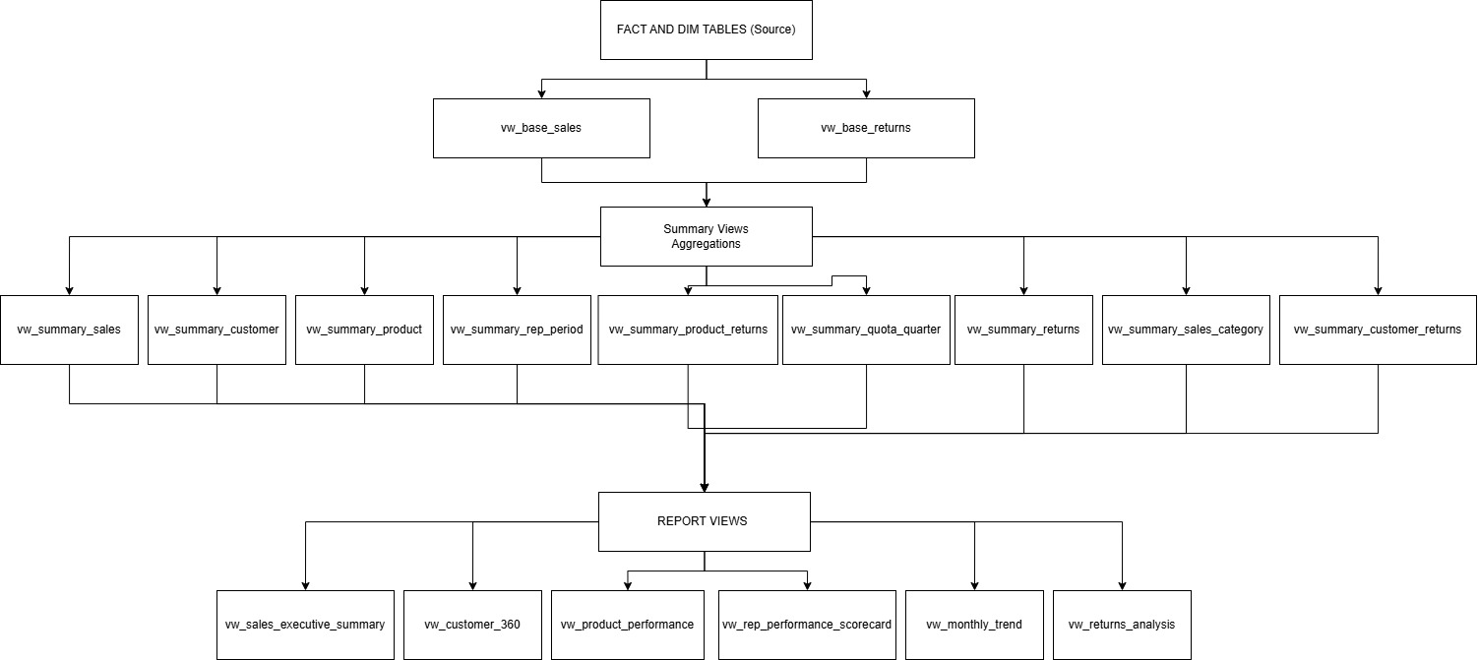
Conclusion
This three-layered architecture provides:
- Clear separation of concerns
- High reusability of views
- Improved performance for reporting and analytics
- Greater flexibility for future extensions and enhancements

